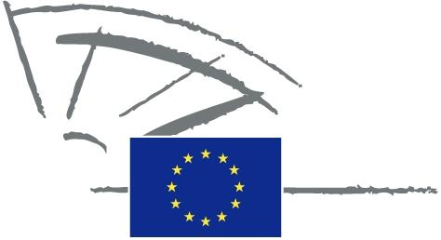
 | EUROPEAN PARLIAMENT | 2009 - 2014

<Date>{15/04/2013}15.4.2013</Date> <NoDocSe>0007/2013</NoDocSe>
<TitreType>WRITTEN DECLARATION</TitreType>
<TitreRecueil>submitted under Rule 123 of the Rules of Procedure</TitreRecueil>
<Titre>on the threat of drug-resistant tuberculosis to the European region</Titre>
<Depute>Claudiu Ciprian Tănăsescu (S&D), Carl Schlyter (Verts/ALE), Esther de Lange (PPE), Anna Rosbach (ECR) Rebecca Taylor (ALDE), Nirj Deva (ECR), Eleni Theocharous (PPE), Michèle Striffler (PPE), Glenis Willmott (S&D), Marek Henryk Migalski (ECR), Marc Tarabella (S&D), David Martin (S&D), Marie-Christine Vergiat (GUE), Edit Bauer (PPE)</Depute>
Lapse date: <DateForclusion>{15/07/2013}15.7.2013</DateForclusion>

0007/2013
Written declaration, under Rule 123 of Parliament’s Rules of Procedure, on the threat of drug-resistant tuberculosis to the European region
1. Tuberculosis (TB) costs the European Union EUR 750 million per year and the European region is home to the highest rates of multidrug-resistant TB (MDR-TB) in the world, accounting for nearly 20 % of the global burden;
2. The World Health Organisation (WHO) Regional Office for Europe launched a ‘Roadmap to prevent and combat drug-resistant tuberculosis’ in the WHO European Region for 2011-2015 and estimates that, if not implemented, the economic loss to the region will be USD 12 billion within five years;
3. The Global Fund to Fight AIDS, Tuberculosis and Malaria has treated 23 000 people for MDR-TB in Eastern Europe and Central Asia since 2002, and there is currently no viable substitute for this fund in the region;
4. The Commission and the Council are hence called upon to back the Global Fund politically and financially, especially in light of its replenishment in 2013;
5. The Commission is called upon to give financial and political backing to the WHO’s roadmap on drug-resistant tuberculosis;
6. The Commission is called upon to support the revision of Global Fund eligibility criteria to ease restrictions on middle-income countries;
7. This declaration, together with the names of the signatories, is forwarded to the Council and the Commission.

In accordance with Rule 123(4) and (5) of Parliament’s Rules of Procedure, when the declaration is signed by a majority of Parliament’s component Members, it shall be published in the minutes with the names of its signatories and forwarded to the addressees, without however binding Parliament.

